LEONARD A. HOMENIUK
PROFESSIONAL ENGINEER #11382204
3339 CLIFF DRIVE, SANTA BARBARA, CALIFORNIA 93109
USA
1(805)886-178
LENANTONC Al@GMAIL. COM
The Office of the Prosecutor General of the Kyrgyz Republic
Bishkek
The Kyrgyz Republic
Attn: Ms. Indira Djoldubaeva - Prosecutor General of the Kyrgyz Republic

June 6, 2016
Dear Ms. Djoldubaeva:
In response to your office's inquiry:
During my entire work at Kumtor Operating Company ("КОС") and Cameco Gold Inc., periodically, several times per year, we received requests from the management of State Concern Kyrgyzaityn (Mr. Dustan Sarygulov and Mr. KamchybekKudaibergenov) and other state agencies, including the President's office and the structures under the leadership of the members of the President's family and other associated persons, for all sorts of financial contribution for various purposes, including for political elections, additional (unscheduled) payments to the Finance Ministry, support of various regional and state funds, etc. Such requirements were sometimes very significant, more than $200,000 in a given month.
Mr. Dustan Sarygulov and Mr. KamchybekKudaibergenov always explained such requests that they were under pressure by the office of the President. According to Cameco Corporation's policy, all such claims were reviewed by senior management of Cameco Corporation and later by the Board of Directors of Centerra Gold Inc. in consultation with corporate counsel. Besides, significant payments were authorized by Cameco Corporation and КОС to be made to the international charitable foundation Meerym, under the leadership of M. Akaeva, the wife of the former President.
Meanwhile, the issue of corruption schemes within the country was very serious at that time, as evidenced by the reports of various international organizations, including the World Bank. Rumors that State Concern Kyrgyzaityn was one of such structures were also quite common.
Despite the compliance with all the technical requirements of anti-corruption legislation, Cameco Corporation and КОС could not ensure the legitimate use or proper documentation of all cash payments which were lawfully made in the Kyrgyz Republic.
Naturally, various payments by Cameco Corporation and КОС to various entities in the Kyrgyz Rebpublic were very significant. The companies were constantly subjected to various claims, however, the Kumtor Project continued to work without interruptions and by and large without undue pressure from the Kyrgyz authorities. It is possible that this partly stemmed from the fact that some cash payments made by Cameco Corporation and КОС legitimately, were used in the Kyrgyz Republic, including by State Concern Kyrgyzaltyn, in unintended ways.

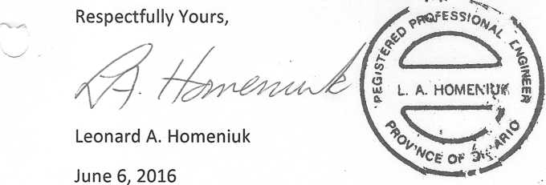

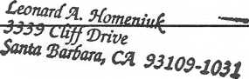
STATE OF CALIFORNIA

__Santa Barbara________________ COUNTY OF SANTA BARBARA
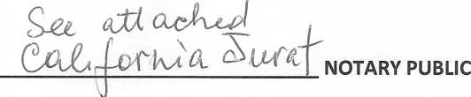

SWORN AND SUBSCRIBED this
6 day of June, 2016.

